Flood Susceptibility Mapping Using SAR Data and Machine Learning Algorithms in a Small Watershed in Northwestern Morocco
Hitouri, S., Mohajane, M., Lahsaini, M., Ali, S. A., Setargie, T. A., Tripathi, G., D’Antonio, P., Singh, S. K., & Varasano, A. (2024). Flood Susceptibility Mapping Using SAR Data and Machine Learning Algorithms in a Small Watershed in Northwestern Morocco. Remote Sensing, 16(5), 858. https://doi.org/10.3390/rs16050858
Imagine waking up one morning to find your home surrounded by rising floodwaters, turning streets into rivers and cutting off entire neighborhoods from the outside world…
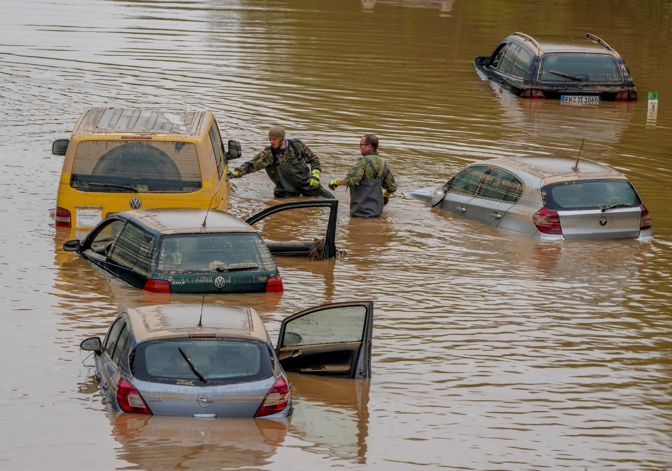
Flood / Lxcbyezyt32stm - Provided by the centers for disease control and prevention (CDC).
This is no longer only a scene in apocalypse movies. Due to climate change, flood events that are previously expected to occur once every 100 or 1,000 years are now happening every year in various regions.
To evaluate and manage regions in flood risk, an essential part is flood susceptibility mapping. Traditional methods, like FEMA flood maps, often take years to update and quickly become outdated. In this study, researchers explore a novel approach—combining Synthetic Aperture Radar (SAR) data with machine learning algorithms to map flood risks in the Metlili Watershed, Morocco. Unlike conventional methods, this new method offers real-time insights by utilizing SAR’s ability to penetrate cloud cover and capture land conditions. At the same time, machine learning models enable the processing and analysis of large volumes of data, enabling the extraction of valuable patterns and relationships that are required for accurate flood susceptibility modeling.

Accurate and up-to-date flood susceptibility mapping can inform urban planning in many ways. Planners can use these maps to identify high-risk zones, guiding land-use decisions and ensuring developments are placed in safer locations. In already built-up areas facing increasing flood risks, cities can retrofit infrastructure to better withstand future flooding. At the same time, strategic planning efforts—such as stormwater management strategies and green infrastructure initiatives—can benefit from flood mapping to create more resilient urban environments.
Data Used In Study
- Flood Inventory Map: Used to extract target variable – a binary variable that determines whether areas are flooded or not. Consists of a local flood inventory data and Sentinel-1 image data.
- Flood Conditioning Factors: Used as model features, all categorical. Numeric factors are categorized by experience and Natural Break method, factors in text are translated to categorical numbers. The factors were then all normalized by min-max method to between 0 to 1. All 12 factors include: elevation, slope, aspect, plan curvature, topographic wetness index (TWI), stream power index (SPI), lithology, distance from roads, distance from streams, land use/ land cover, NDVI, rainfall patterns. Data sources include DEM data, Landsat-8 images, ERA rainfall data, and local data sources.
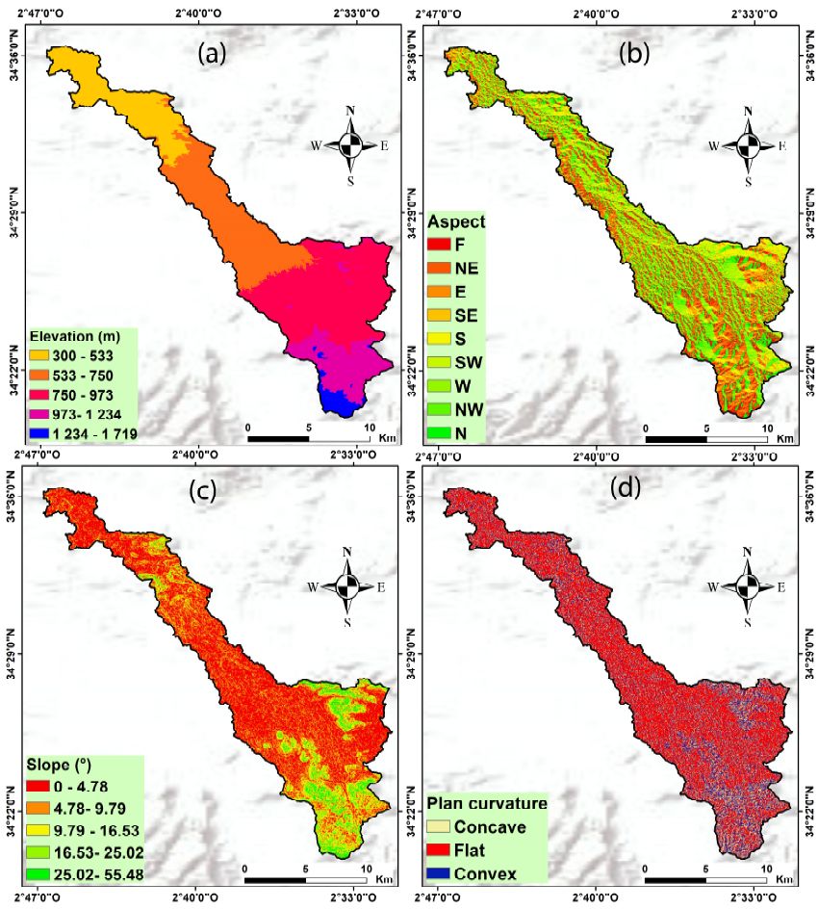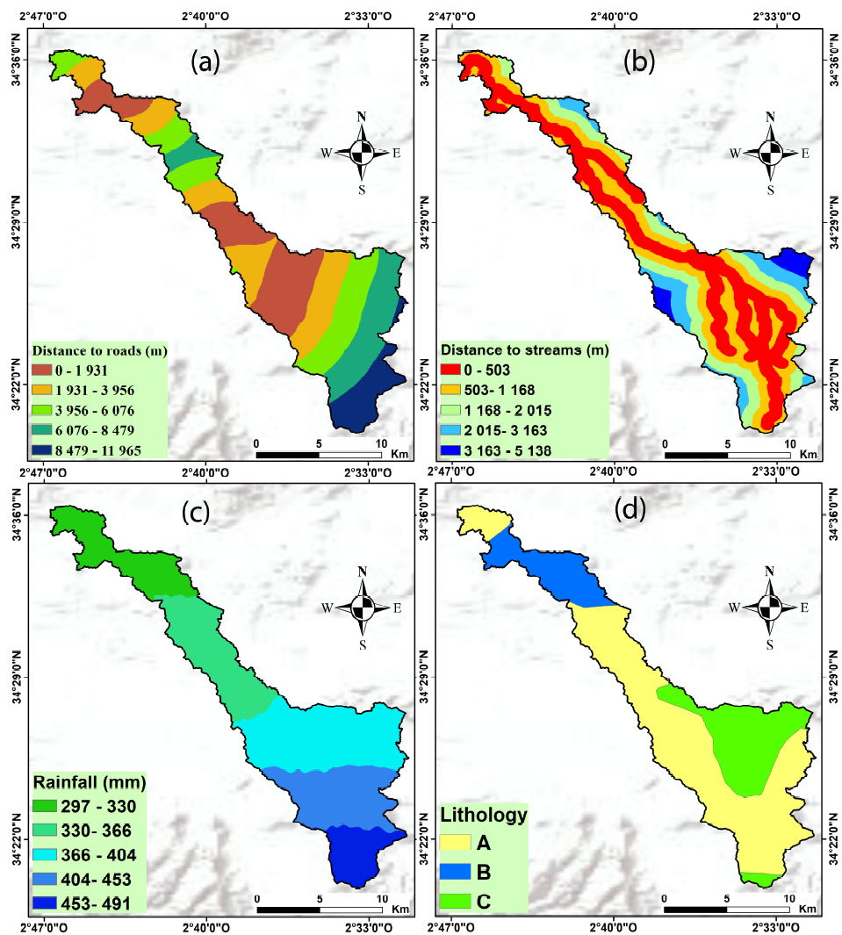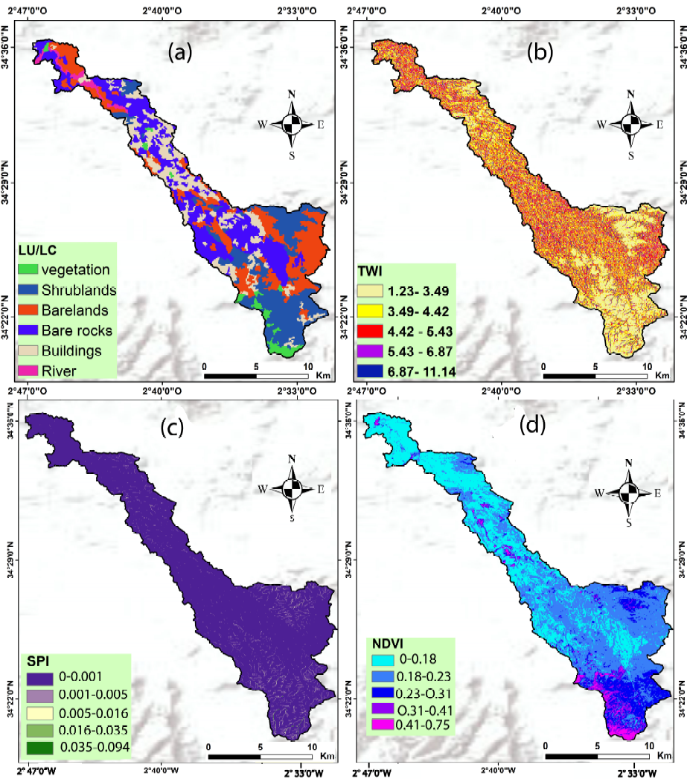
Flood Conditioning Factors / Hitouri, S. et al.
Data Scale: In 30m x 30m cells.
Machine Learning Methods Used In Study
- 4 different algorithms are tested and compared in the study, including Random Forest (RF), Classification and Regression tree (CART), Support Vector Machine (SVM), and Extreme Gradient Boosting (XGBoost).
- Data was split into a training dataset (70% of the data) and a validation dataset (30%).
- Predictions were also categorized into 5 classes representing very low, low, moderate, high, and very high flood risk levels across different areas.

Results
- The authors produced 4 predicted flood susceptibility maps with 4 different machine learning algorithms.
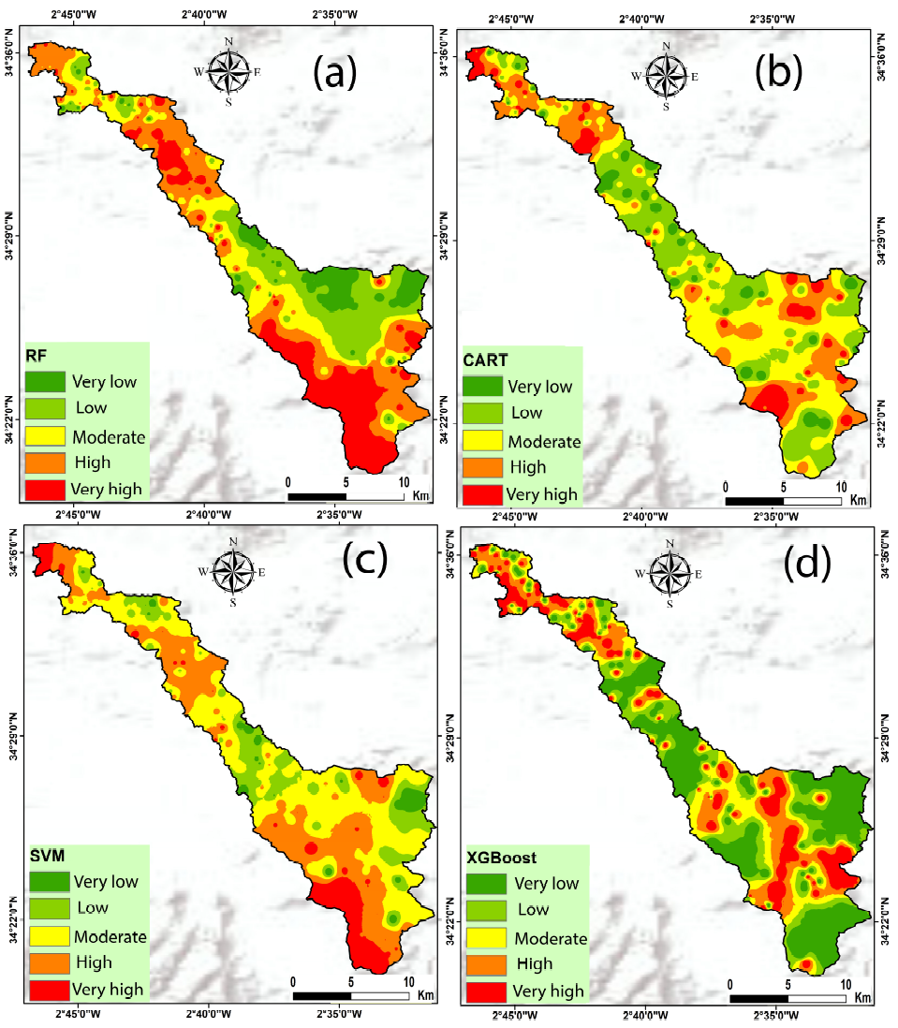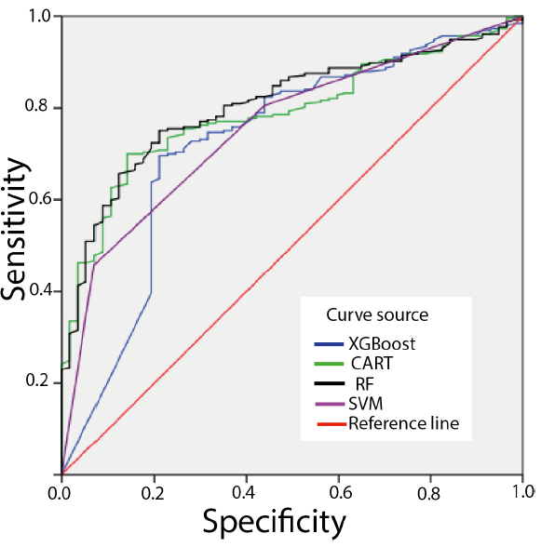
Left: Flood Susceptibility Maps; Right: ROC Curves of 4 Algorithms / Hitouri, S. et al.
- Random Forest was chosen as the best prediction model, due to it having the largest Area Under ROC Curve (AUC) of 0.807.
Question for Further Thought
Instead of using annual precipitation rate as “rainfall pattern” factor, can this model incorporate real-time weather and water data (temporal factors) to predict flood possibility for the next time interval in areas?

